TASK 5 Solutions

Q1 Solution

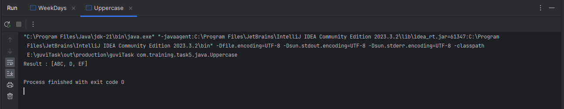

Q2 Solution

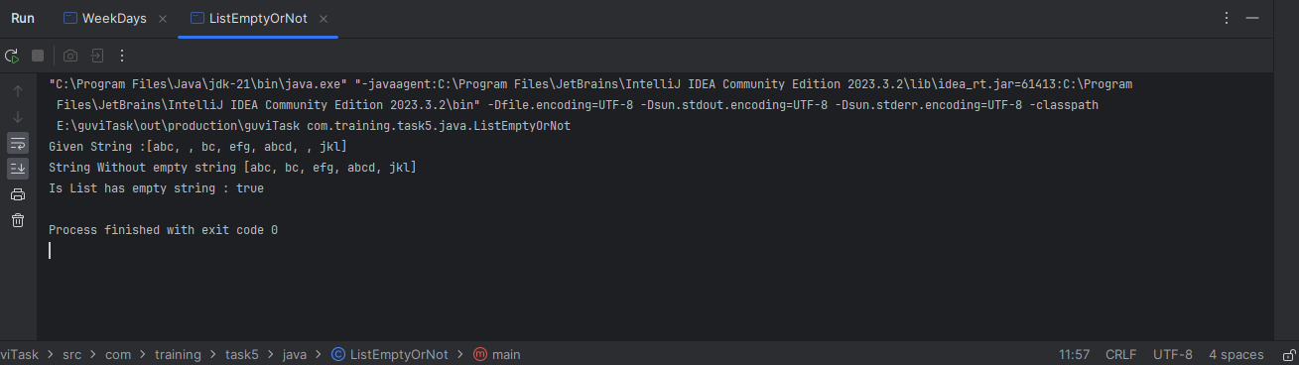

Q3 Solution

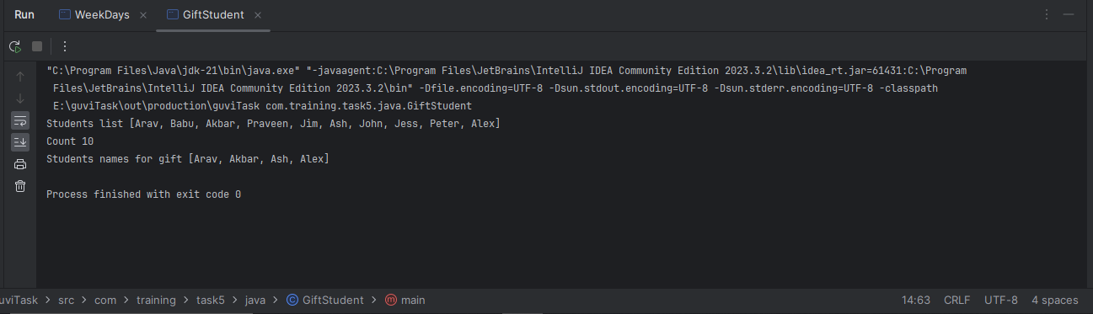

Q4 Solution

